**A.1 List and explain five of the functionalities that you see as a “must have” in a “Test and Defect (Bug) Tracking Management Tool” and state the benefits of each of these functionalities from a Test Manager’s point of view (10 marks)**

1. Incident Management: The tool should allow tracking and managing incidents (bugs, issues, defects) found during testing.

Benefits: Test Managers can efficiently resolve incidents, ensuring timely bug fixes and improved software quality.

2. Collaboration: The tool should enable team members to collaborate on incident identification and resolution.

Benefits: Test Managers can facilitate effective communication and teamwork, leading to thorough incident analysis and resolution.

3. Traceability: The tool should provide traceability of incidents to test cases and requirements.

Benefits: Test Managers can analyze the system's quality, identify areas for improvement, and ensure requirements are met.

4. Customizable Workflow: The tool should allow customizing workflows for different incident types.

Benefits: Test Managers can streamline the incident resolution process and improve efficiency by defining specific rules and operations for each incident type.

5. Reporting and Metrics: The tool should offer comprehensive reporting and metrics related to testing and incidents.

Benefits: Test Managers can assess testing progress, incident trends, and overall quality, enabling informed decision-making and effective communication.

**A.2 In Chapter 1 “An Exciting Career in Entomology Awaits You” Rex Black starts by breaking the test effort into 5 major phases. List them with a brief explanation. (15 marks)**

1. Planning: Establishing objectives, scope, and approach for testing.

2. Configuration: Setting up the necessary resources and test environment.

3. Staffing: Selecting and forming the test team.

4. Test Development: Building test tools, creating test suites, and documenting the process.

5. Test Execution: Running tests, recording status, and reporting results.

**A.2 Name and discuss the components in an “Automation Test System Architecture” and explain the interactions between these components. (15 marks)**

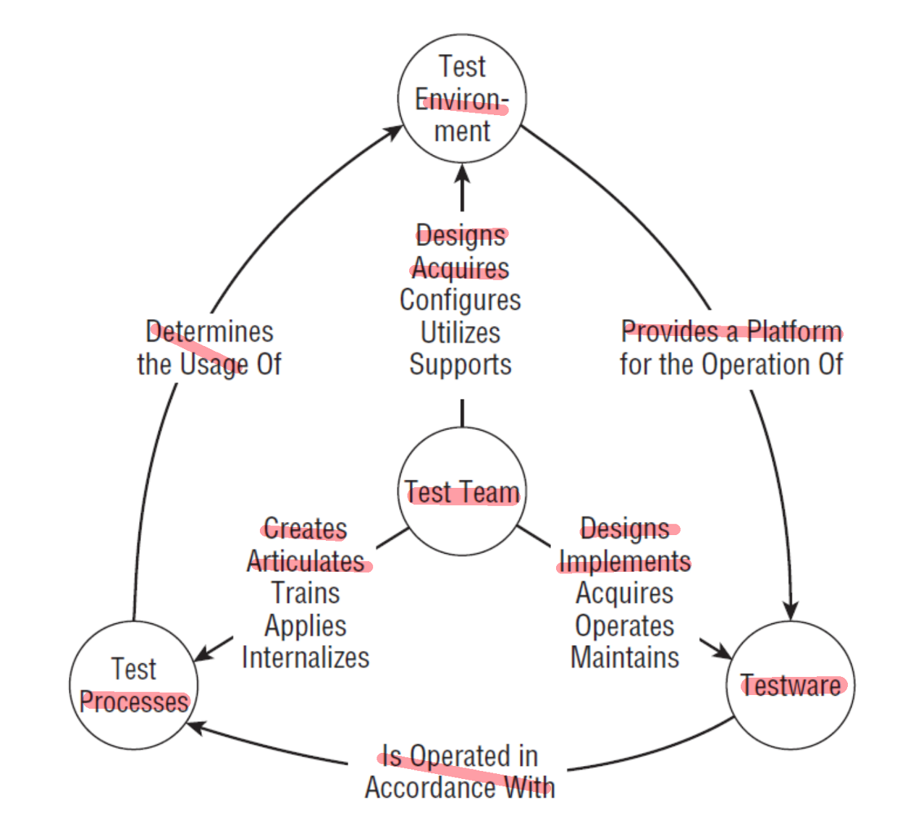

**A.2 In Chapter 3 “An Exciting Career in Entomology Awaits You” Rex Black provides a visual representation of the test ware, a model; that he found useful in thinking about and communicating the structure and mechanics of test systems. Please draw that model and explain in detail (15 marks)**

One or more test tools – e.g., operating systems, scripting languages, GUI test automation systems, API test harnesses, oscilloscopes, or thermal chambers, etc.

Result logs produced using these tools – either created automatically from the tool or logged manually by the tester Test Case Library supported by the Test tools – many-to-many relationship

Reporting tools – Both the test case library and the result logs feed into reporting tools

Test Suits assembled from the Test Case Library – the relationship between cases and suites is also many-to-many

Test Reports – from the test suites and the reporting tools come test reports

The test plan is a document that defines how the test system will be used to test the software.

**A.2 In Chapter 1 “An Exciting Career in Entomology Awaits You” Rex Black name five of quality risk analysis Techniques and Templates, he discussed two most commonly used. Name these two and explain what FMEA means. (16 marks)**

The Classics and Beyond:

Failure Mode and Effect Analysis:

(FMEA) is an approach which called failure mode and effect analysis, used to define quality risks. It could map requirements, design specifications, and project team assumptions onto specific quality risks and effects.

**A.3 Discuss Two Main Key factors which need to be considered for building the Test Lab. (5 marks)**

Infrastructure: includes hardware, software, and networking components.

Configuration management: ensures consistency and stability in the test environment.

**A.4 Discuss Two Main Usage of Test Plan and Test Summary Report (5 marks)**

**Test Plan:**

Given a budget, resource commitments, and a schedule

Specific details of test suites

**Test Summary Report:**

provides an overview of test outcomes, including passed, failed, and blocked test cases.

assesses test coverage and completion, highlighting gaps and overall testing status.

**B.1 In Chapter 4 “An Exciting Career in Entomology Awaits You” Rex Black have been “developed a 10-step process” that he “use as a guideline and checklist for experienced testers, and as a training tool for people new to testing”. Name that process and explain any 5 steps from it. (15 marks)**

\1. Structure: Test thoughtfully and carefully, whether you’re using reactive techniques, following scripted manual tests, or running automated tests.

\2. Reproduce: My usual rule of thumb is to try to reproduce the failure three times. If the problem is intermittent, report the rate of occurrence; for example, one in three tries, two in three tries, and so forth.

\3. Isolate: See if you can identify variables — for example, conﬁguration changes, workﬂow, data sets — that might change the symptoms of the bug.

\4. Generalize: Look for places that the bug’s symptoms might occur in other parts of the system, using different data, and so forth, especially where more severe symptoms might exist.

\5. Compare: Review the results of running similar tests, especially if you’re repeating a test run previously.

\6. Summarize: Write a short sentence that relates the symptom observed to the customers’ or users’ experiences of quality, keeping in mind that in many bug review or triage meetings, the summary is the only part of the bug report that is read.

\8. Be clear: Use clear words, avoiding especially words that have multiple distinct or contradictory meanings; for example, ‘‘The ship had a bow on its bow,’’ and ‘‘Proper oversight prevents oversights,’’ respectively.

**B.2 How do you evaluate Individual Tester Performance as Test Manager? (5 marks)**

**B.2 Discuss briefly the full lifecycle of a bug (defect), draw diagram. You need to cover all the various states that a bug may go through from its birth to its demise. (15 marks)**

**B.2 In Chapter 4 “An Exciting Career in Entomology Awaits You” Rex Black have been suggested to institute a root cause analysis process and a bug taxonomy”. You should explain of the connection between root causes and bugs with the sequence of events by draw a diagram/ model, that will illustrate the connection between bugs and their root causes, explain it.**

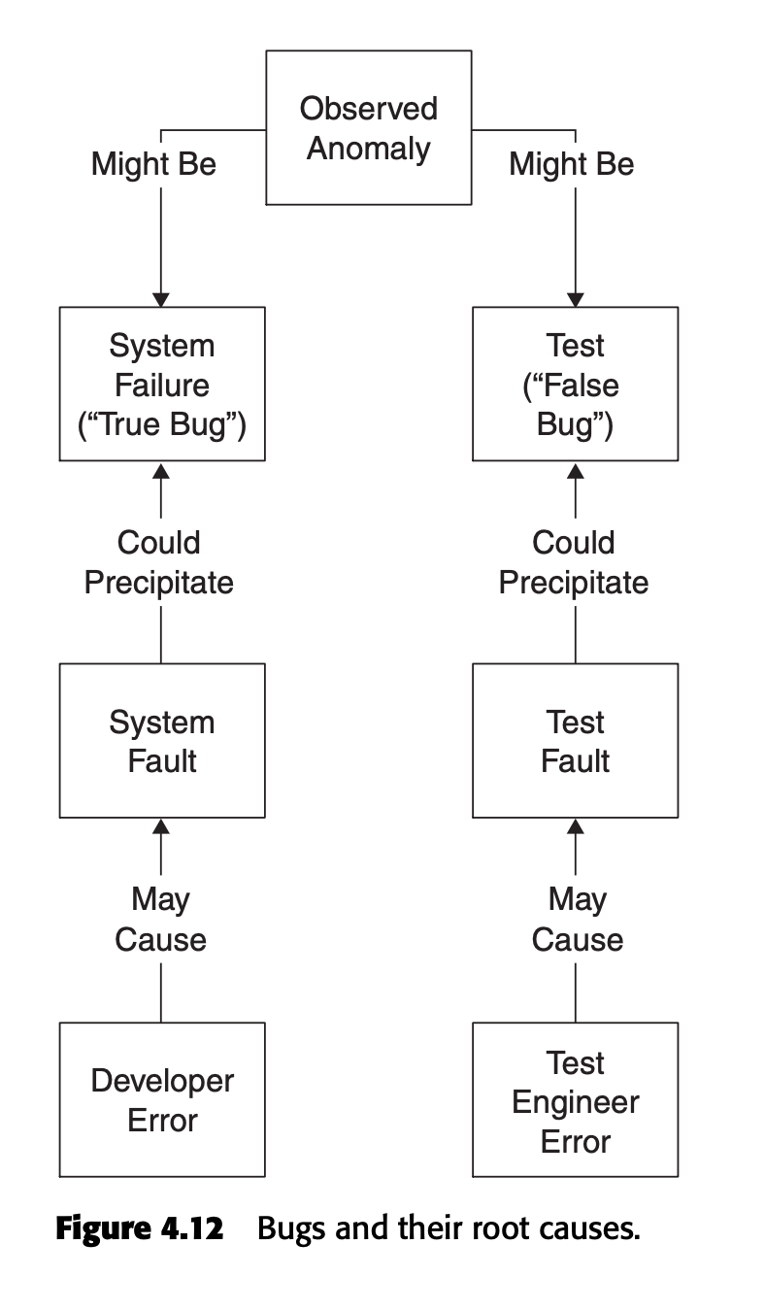

**B.3 Discuss the 5 Main usage of Traceability Matrix and Test Documentation. (10 marks)**

**B.3 As a Test manager you need to develop an online entry form for test cases, which will be implemented as part of a test tracking system. What should be included in it? Explain the reasons why you need to collect this information. (7 marks)**

**B.3 In Chapter 4 “An Exciting Career in Entomology Awaits You” Rex Black have been suggested a basic template for the test case. What should be include in it, explain the reasons why we need to collect this information. (7 marks)**

**C.1. Explain what PUM and BMI stands for in Software Quality Metrics. How PUM and BMI should be calculated? (12 marks)**

PUM (Percentage of Unmodified Modules):

PUM = (Number of Unmodified Modules / Total Number of Modules) * 100

BMI (Bugs per Modified Instruction):

BMI = (Number of Bugs / Number of Modified Instructions)

**C.1. Define and discuss: Quality control and Quality Assurance. Provide three main differences between these two terms. (10 marks)**

**C.1. In Chapter 1 “An Exciting Career in Entomology Awaits You” Rex Black develop the list of major quality risk categories, he starts by breaking down the test process into the phases of component testing, integration testing, and system testing. He defined 23 major quality risk categories during system and acceptance tests. List eight of them and give example for each . (16 marks)**

**C.2. Name and Explain in short for any 3 out of 7 Tools of Quality in Total Quality Management (6 marks)**

**C.2. Explain difference between errors, defects, faults, and failures (IEEE/ANSI). (8 Marks)**

Errors are human mistakes or deviations from the expected behavior.

Defects are flaws in the software that cause it to behave incorrectly.

Faults are the underlying causes of defects.

Failures are observable deviations from the expected behavior of the software.

**C.3. Name and define types of Software Quality Metrics. (9 marks)**

**C.3. Name and discuss any Five Points out of Edward Deming’s 14 Points of Management. (10 marks)**

**C.3. Capability Maturity Model for Software (CMM) has five levels. State and briefly explain each of these five levels in appropriate logical order. (10 Marks)**

**C.4. Define and Discuss: Quality Control and Quality Assurance. Provide two main differences between these two terms? (8 marks)**

**SECTION D THEORY 12 MARKS**

**D.1 Please define and discuss the following terms:**

**a. Quality Control**

**b. Quality Assurance**

**c. FMEA**

**d. Teardown**